Exercise partitions Unit 2

* I create a new 10GB disk

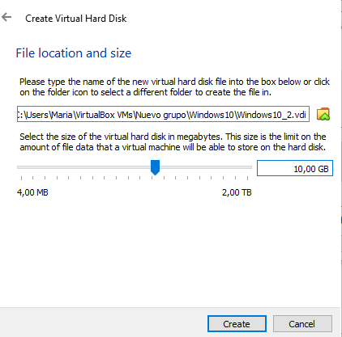

* After this I add the ISO needed for this exercise

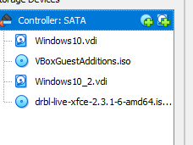

* I run the virtual machine and I chose the different settings (language and keybord)

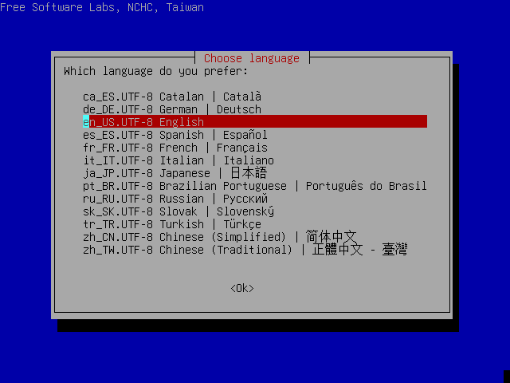

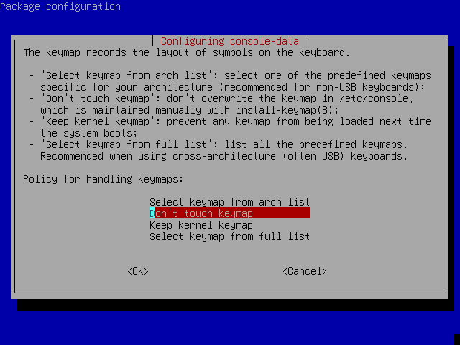

* After this I open Gparted
* I had to change the disk and chose the 10GB one

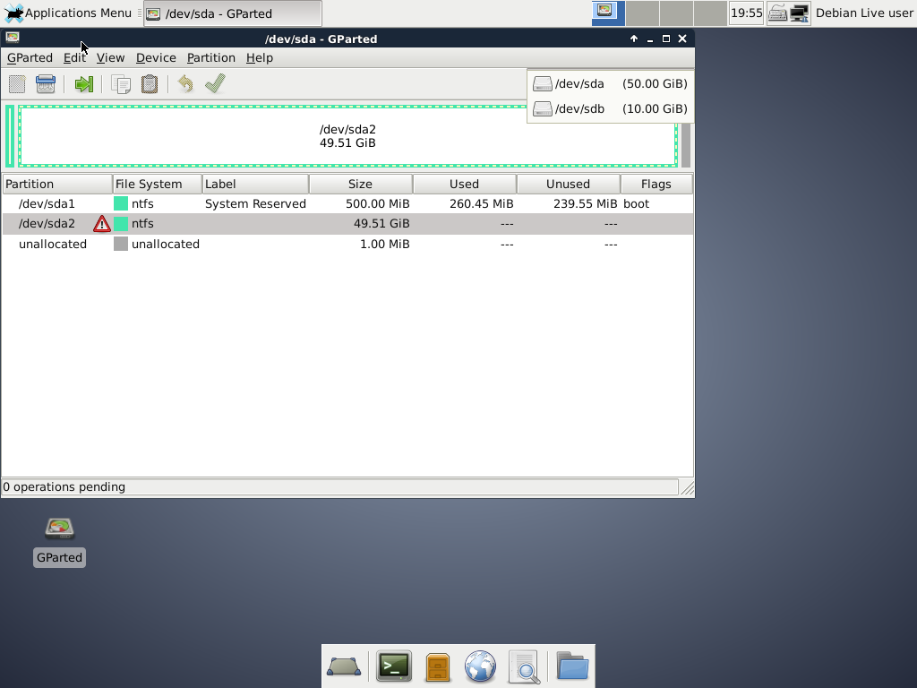

* Clicking on Device and then Create a partition table appears this window

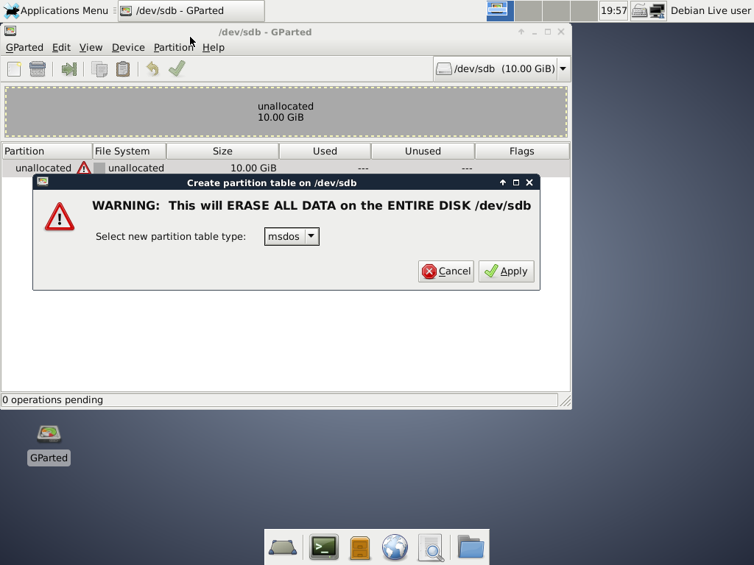

* I create the first partition, in this case a Primary on of 2GB with a file system NTFS and name PNTFS

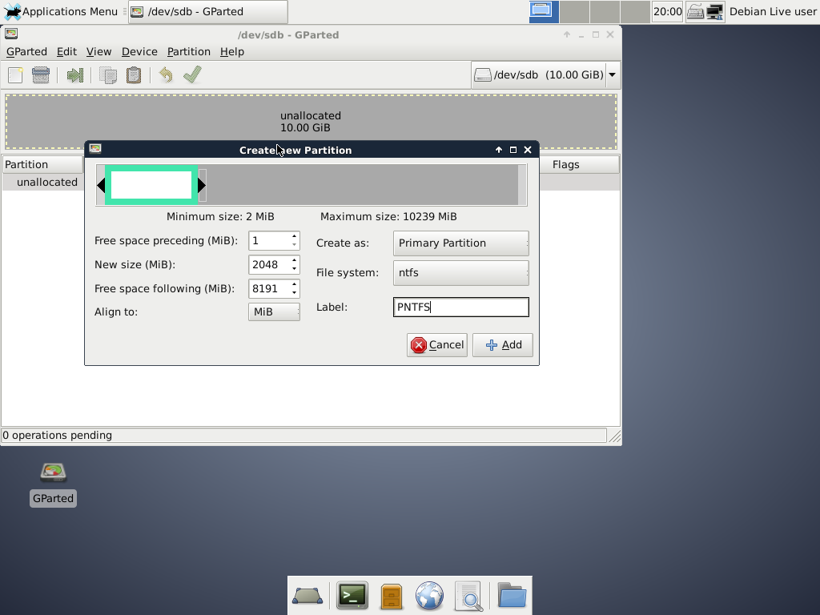

* I create another Primary partition also with 2GB, but with EXT4 file system and PEXT4 label

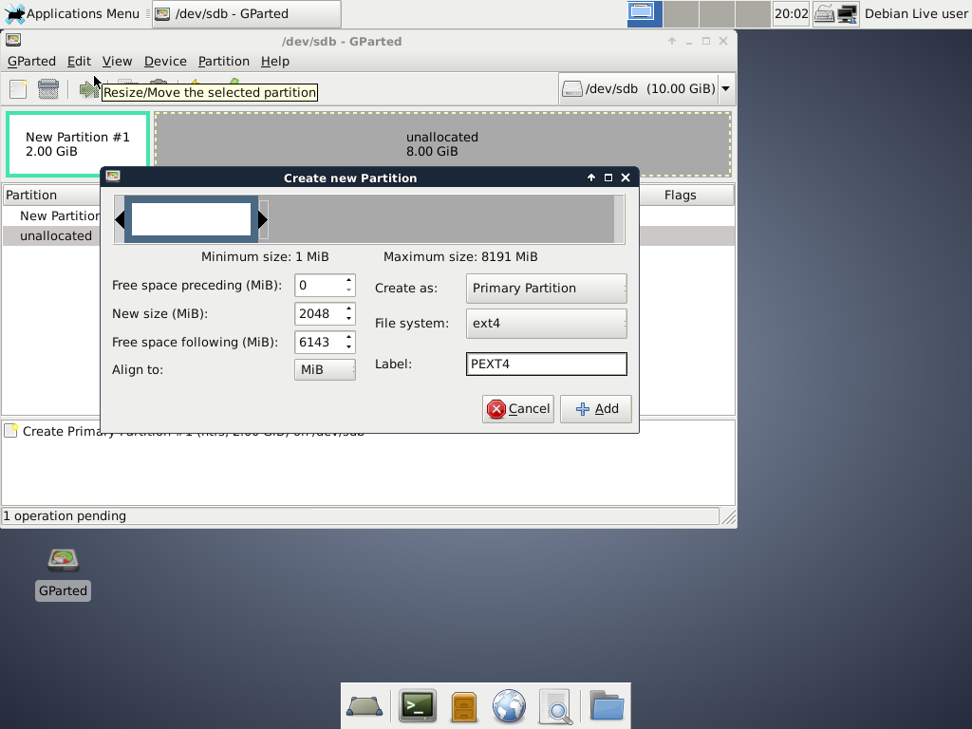

* Now I create an Extended partition PEXTENDED as lebel

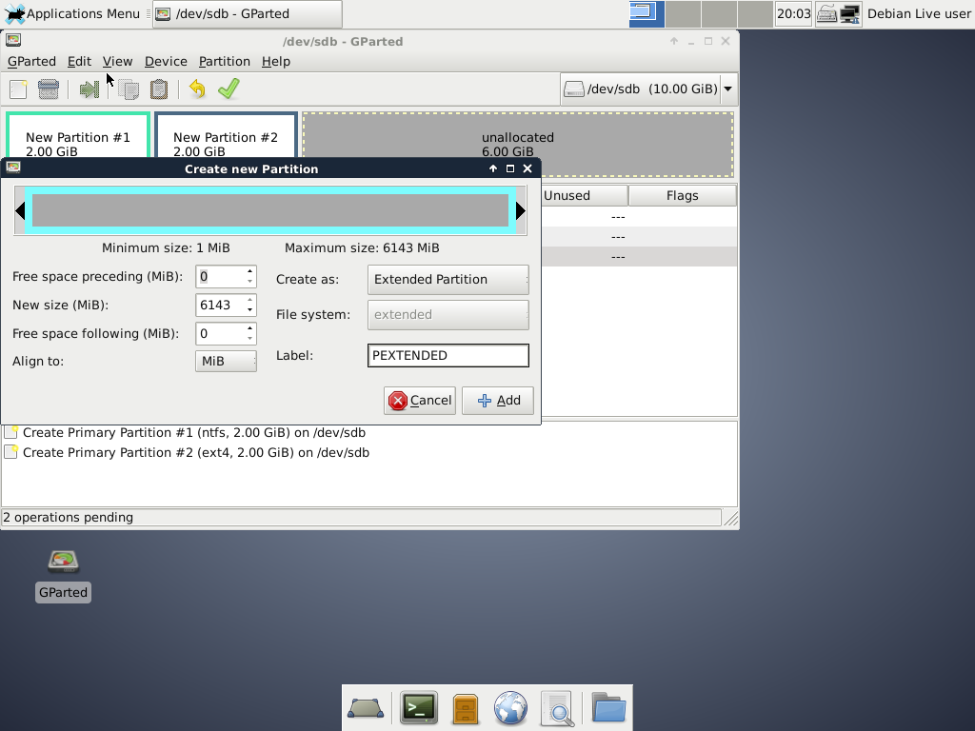

* After this I resize It because I put more space than I need (4096)
* I create the last partition, a logical one, with 2GB, FAT32 file system and PFAT32 label

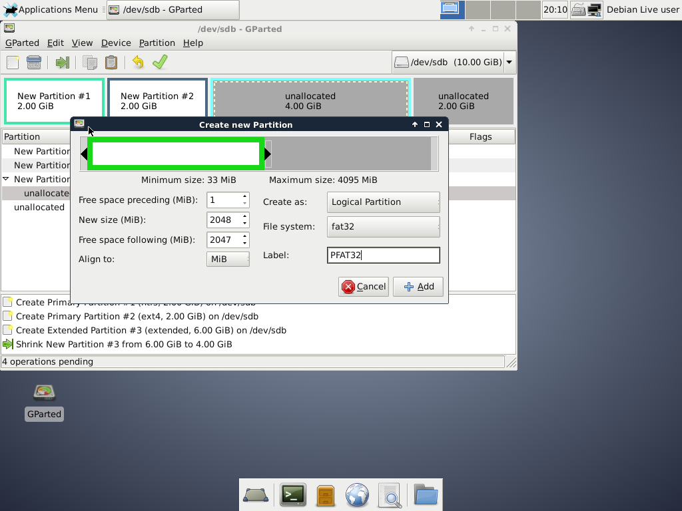

* Finally, I apply the changes

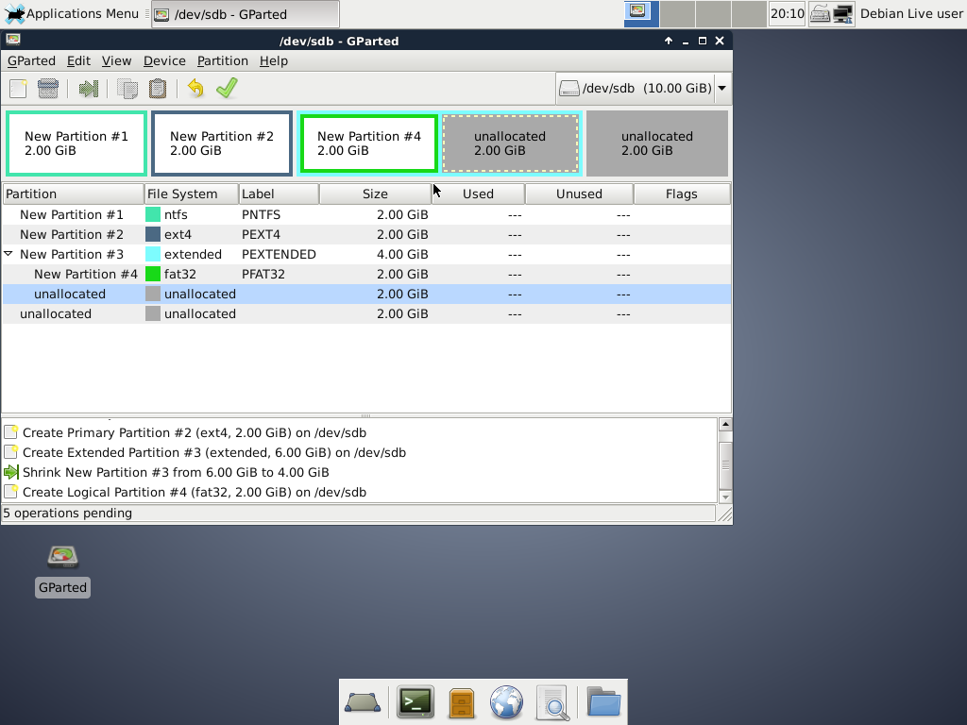

* Why is the file system not showed in second partition?

This is because the file system is not recognised by Windows

* If you had to create a new partition to store 2GB data, where would you put the partition in? Which file system should you use? Justify your answer

In this case we can use booth, inside the extended partition or outside as a primary partition.

About the file system I would use NTFS, FAT32 or FAT16 because we are using Windows

Exercise 2

* I create a new hard disk but this time with 5GB memory

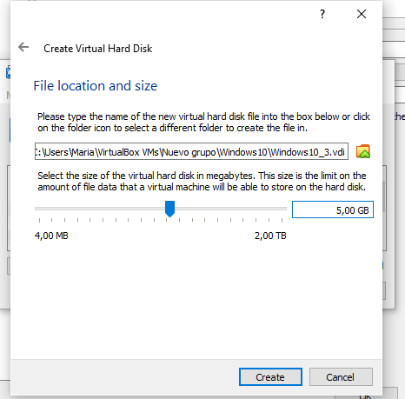

* After making every partition like in the previous exercise I get this

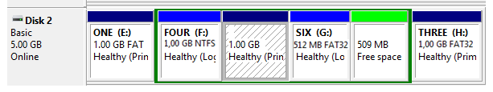

* How does GParted name the hard disk?

It calls it dev/sdc

* List all the partitions you have created, indicating type and file system.

I create a Primary partition first with 1GB, Label ONE and file system FAT32, then I created an extended one of 3GB.

Inside this one I create three logical partitions

* Label FOUR, 1GB, NTFS
* Label FIVE, 1GB, ext4
* Label SIX, 512MB, FAT32

And finally I create another primary partition, with 1GB, label THREE and, FAT32.